TestNG – It is a testing framework which is an abbreviation for Testing New Generation.

It is basically allow the user to control the flow of execution.

Features of TestNG:

1. Execution flow can be decided from user.

2. Pre and post action with respect to test case can be defined.

3. Parallel testing can be performed.

4. Generate the emailable - report based on the execution status.

5. Test case pass / fail / skipped status can be decided using assertions in TestNG.

Installation process of TestNG:

1. Go to help and then –click on Eclipse market place

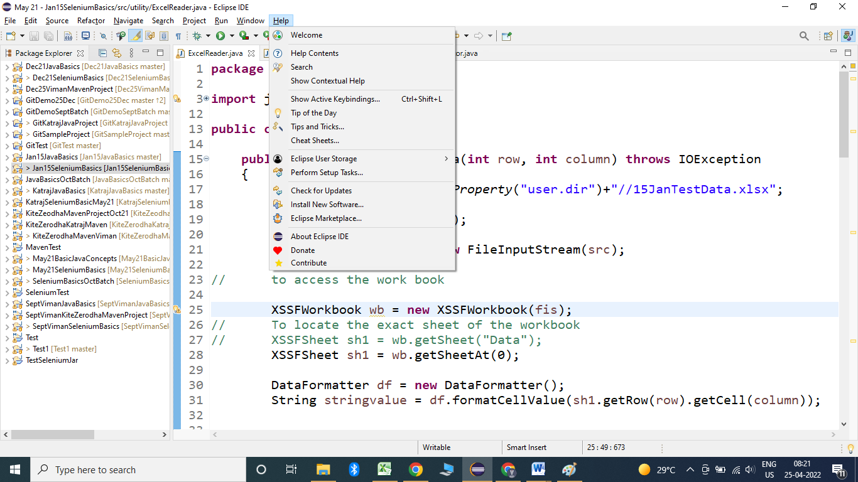

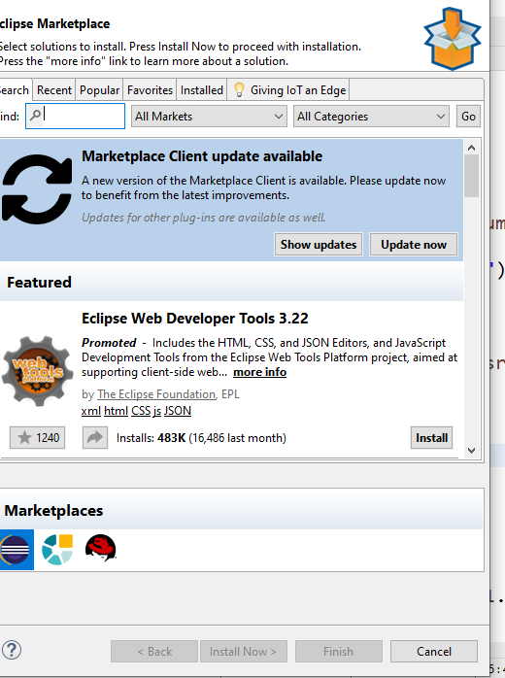

Type TestNG in the text box and click on go.

Click on install:

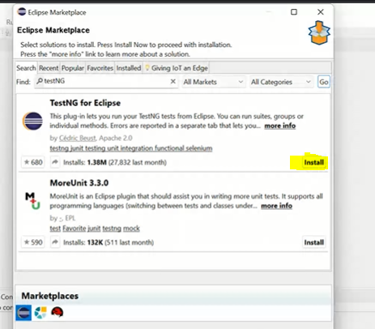

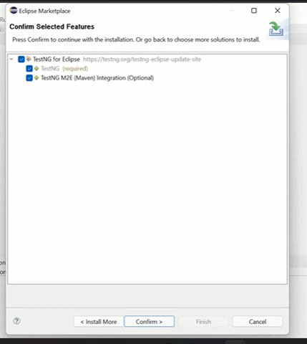

Click on confirm button

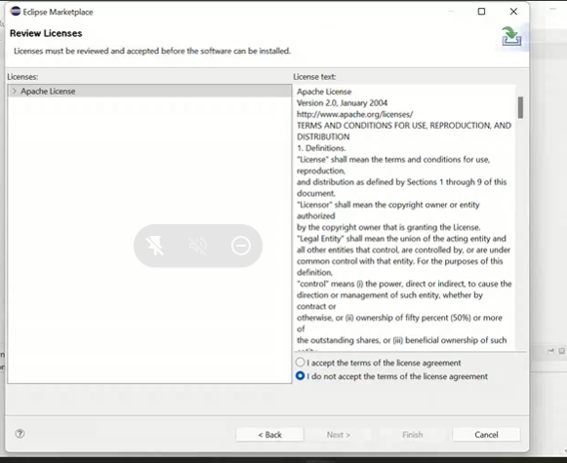

Click on I accept and finish

Execute process of test case:

**public** **class** SingleClassExecution {

@Test

**public** **void** testCase1()

{

System.***out***.println("Test case 1 executed");

}

@Test

**public** **void** testCase2()

{

System.***out***.println("Test case 2 executed");

}

}

To execute Rightclick inside the class and select Run As --- TestNG Test

Output:

Test case 1 executed

Test case 2 executed

PASSED: testCase1

PASSED: testCase2

===============================================

Default test

Tests run: 2, Failures: 0, Skips: 0

===============================================

To see the report of the execution:

Refresh the project – go to test output folder – emailable report

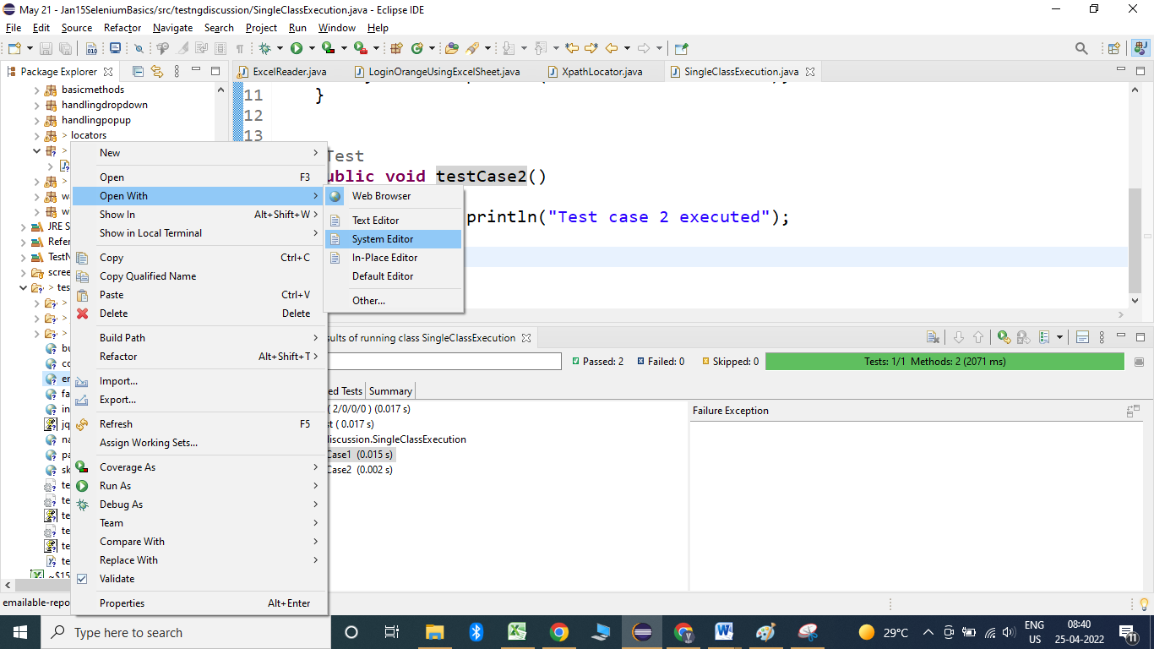

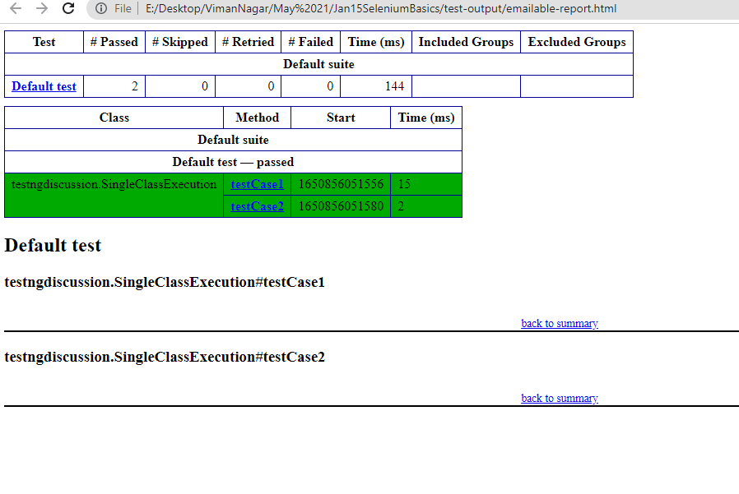

Test cases always get execute in the dictionary order.

Example:

**public** **class** SingleClassExecution2 {

@Test

**public** **void** login()

{

System.***out***.println("Login to application");

}

@Test

**public** **void** dashBoard()

{

System.***out***.println("DashBoard Test case");

}

@Test

**public** **void** profile()

{

System.***out***.println("Profile Test case");

}

@Test

**public** **void** home()

{

System.***out***.println("home Test case");

}

@Test

**public** **void** logout()

{

System.***out***.println("logout Test case");

}

}

Output:

DashBoard Test case

home Test case

Login to application

logout Test case

Profile Test case